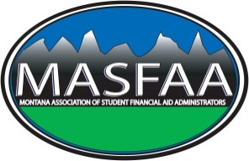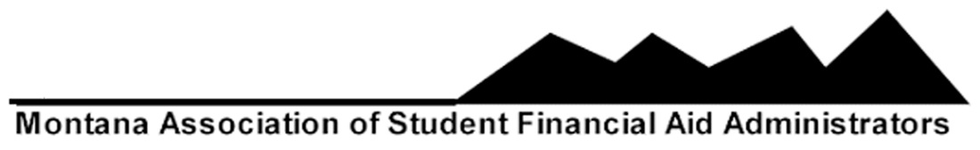

**MASFAA Transitional Board Minutes**

**Location: Conference Call**

**Friday, September 18, 2015 2:30 pm**

1. **Call Meeting to Order:**

Roxy Jacobson makes a motion to call the meeting to order

Rita Larby seconds the motion

1. **Approve Agenda**

Sandy Johnsrud makes a motion to approve the agenda

Rita Larby seconds the motion

1. **Approve Minutes**

Roxy Jacobson makes a motion to approve the minutes

Tina Wagner seconds the motion

1. **Robert’s Rules of Order and Voting Protocol**
2. **Policies and Procedures, Bylaws and Board Responsibilities**
   1. Review and suggested changes

Suggestions to the P & P sent out for review by Tina Wagner

*(see attached)*

1. **MASFAA Finances and Expense Reports**
   1. 2015 Budget Update/Discussion

Tina did the budget for 2015

* 1. 2016 Budget Discussion

There is no budget yet for 2016

Sandy - $9877.00 cleared from MCAN seed money. Use some for scholarships?

1. **Officers Reports**
   1. **Past-President, Tina Wagner**

Nothing to report

* 1. **Vice President/Secretary, Julie Watson**

Nothing to report

* 1. **President-Elect, Emily Williamson**

Was not present

* 1. **Treasurer, Sandy Johnsrud**

Expressed a concern since there is no First Interstate Bank where she is

* 1. **Member-at-Large, Alexa Freeburg**

Nothing to report

* 1. **Member-at-Large, Rita Larby**
  2. Nothing to report
  3. **Associate Member, Roxy Jacobson**

Nothing to report

* 1. **President-Kelli Engelhardt**

Watching for fall training from NASFAA

1. **Old Business**
   1. **2015 Spring Conference Feedback**
   2. **Membership Surveys**

Should we continue? MCAN combined was mostly positive. The feedback has been

helpful. Question whether people are always being completely honest on surveys.

Use of “Survey Monkey” to gain feedback on programs, websites, materials, etc.

1. **New Business**
   1. **Social Media Ideas**

Are there ways to include in our preferences? Can we “tackle” this as a project?

Tina: our website is underserved and could be improved. Listserv maybe used more for introducing new people. Incorporate day to day things, “what are people doing”? We can look a RMASFAA (<http://rmasfaa.org/> ) and what is being done there such as the blog: also look at what other schools are doing as a means for updating our website and other resources. Standing as an open ended discussion. As a continuance of this discussion, every board member was going to look over a state website to see what they were doing and report at the next board meeting.

Julie – Colorado (CAFAA - <http://www.cafaa.org/> )

Roxy – Kansas (KASFAA - <http://www.kasfaa.org/> )

Sandy – Nebraska (NeASFAA - <http://www.neasfaa.org/> )

Alexa – North Dakota (NDASFAA - <http://www.ndasfaa.org/> )

Kelli – South Dakota (SDASFAA - <http://www.sdasfaa.org/> )

Tina – Utah (UASFAA - <http://uasfaa.org/> )

Rita – Wyoming (WYASFAA - <http://wyasfaa.org/> )

* 1. **Spring Conference –April 6-8 Billings, MT – Emily Williamson**

Emily was not present on this conference call

Discussed $5000.00 budget. Requested several bids. Looking to have Deb Tarpley and

Joe Donlay. Was there anything else to be aware of?

Next meeting December 10th from 2:30-3:30 has been rescheduled for Wednesday

December 16, 2015 from 3:00 – 4:00 PM MT.

1. **Adjourn**

Julie moved to adjourn

Roxy seconded